**Assignment 1**

**Name : Manasa Vathumilli**

**Student id : 700745467**

**Q1) Sort the list of ages, find min and max, average, median and range**

#statistics module. It provides some functions for calculating basic statistics on data like mean, median

import statistics

ages = [19, 22, 19, 24, 20, 25, 26, 24, 25, 24]

#sort() function to sort the list and min(),max() to find minimum and maximum values of list respectively.

ages.sort()

print("Sorted ages: ", ages)

print("Minimum value of ages: ", min(ages))

print("Maximum value of ages: ", max(ages))

# insert(position, value) - inserts the value in list at specified position\n",

ages.insert(0,min(ages))

# append(value) - appends the value at the end of list\n",

ages.append(max(ages))

print("List after update: ", ages)

#The biggest advantage of using median() function is that the data-list does not need to be sorted \n",

#before being sent as parameter to the median() function using statistice module\n",

print("Median of ages: ", statistics.median(ages))

print("Average of ages: ", statistics.mean(ages))

print("Range of ages: ", max(ages)-min(ages))

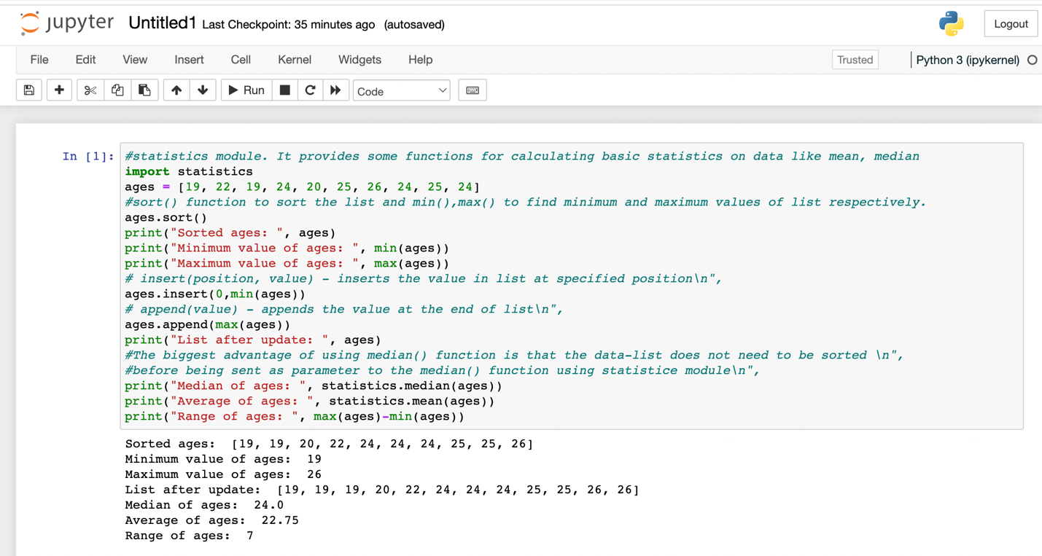

→From the above given list I have found the minimum and maximum ages of students and also added the minimum and maximum age to the list again and also found the median age by dividing it by two and average by adding all the items and then dividing by their number and at last finding the range of the ages

**Q2) Create a dictionary**

dog= dict()

#update() method inserts the specified dictionary or any key-value pairs to the resp. dictionary\n",

dog.update({"name":"Fluffy", "color":"Brown", "breed":"Poodle", "legs":4, "age":4})

print("Added key-value pair to dog: ",dog)

#used dict() function which creates a empty dictionary\n",

student_dict = dict()

keyList = ["first_name", "last_name", "gender","age","marital status","skills","country","city","address"]

#added only keys to the dictionary with None value using update method\n",

student_dict.update({key: None for key in keyList})

print("\nStudent_Dictionary after adding keys: ",student_dict)

#utilised len(dictionary) function to calculate lenght\n",

print("Length of Student_Dictionary: ", len(student_dict))

#updated student_dict with sample values\n",

student_dict.update({"first_name": "Manasa", "last_name": "Vathumilli", "gender": "Female", "age": "24","marital status": "Single", "skills": ["Java","Python"], "country": "India", "city": "Hyderabad","address": "48-447/2"})

print("\nStudent_dict ", student_dict)

#accessing paritcular value of key in dict: dict[\"key\"]\n",

print("\nAccessing Skills value in dictionary: ",student_dict["skills"])

#type(value) - function gives the datatype of provided values\n",

print("Data Type of Skills in Student Dict: ", type(student_dict["skills"]))

#The extend() adds all the elements of an iterable (list, tuple, string etc.) to the end of the list\n",

student_dict["skills"].extend(["Apex", "JavaScript"])

print("Updated Skills list after adding new values: ", student_dict["skills"])

# dict.keys() and values() gives the list of keys and values as a list respectively\n",

print("\n",student_dict.keys())

print(student_dict.values())

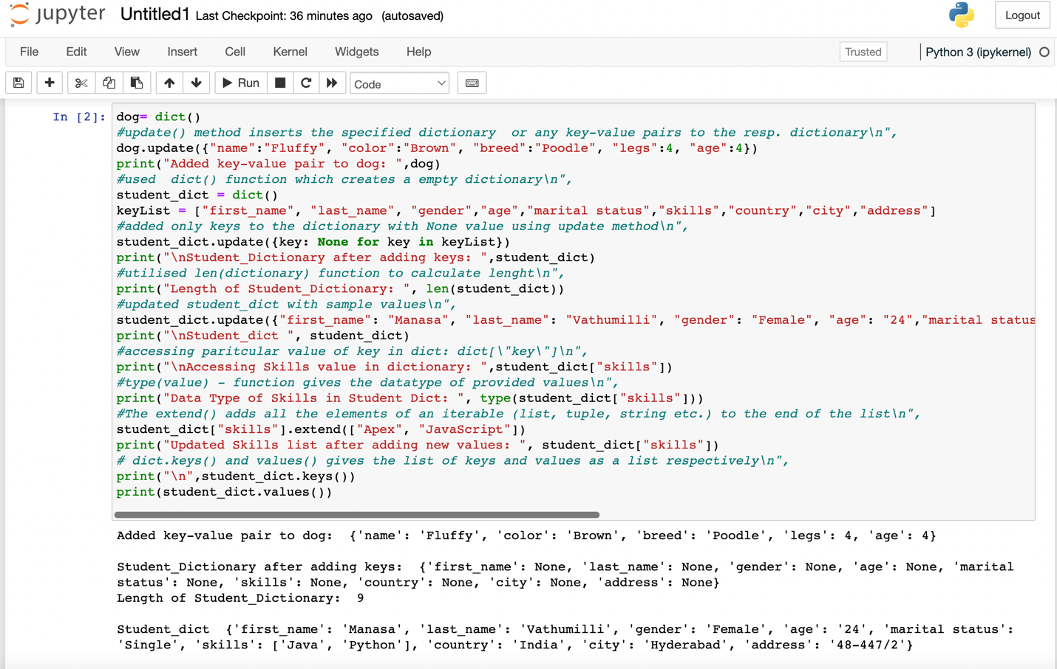

  
→first I had created an empty dictionary and name it as dog, then added the name , color, breed, legs and age to the dog dictionary. And then I have created a student dictionary and added keys as , country, city, the first_name, last_name, gender, age ,marital status, skills, country, city and address. I found the length of the student dictionary checking the data type and modify the skills values and adding one or two skills and finally getting the dictionary keys and dictionary values as a list.

**Q3) Create tuple of sisters and brothers**

sisters = ("Sushmaja","Priya")

print("Sisters: ", sisters,)

brothers = ("Rajesh","Uttej")

print("Brothers: ", brothers)

siblings = sisters+brothers

print("siblings: ",siblings)

print("Number of Siblings:", len(siblings))

family_members = siblings+("Prasad","Durga")

print("family_members: ", family_members)

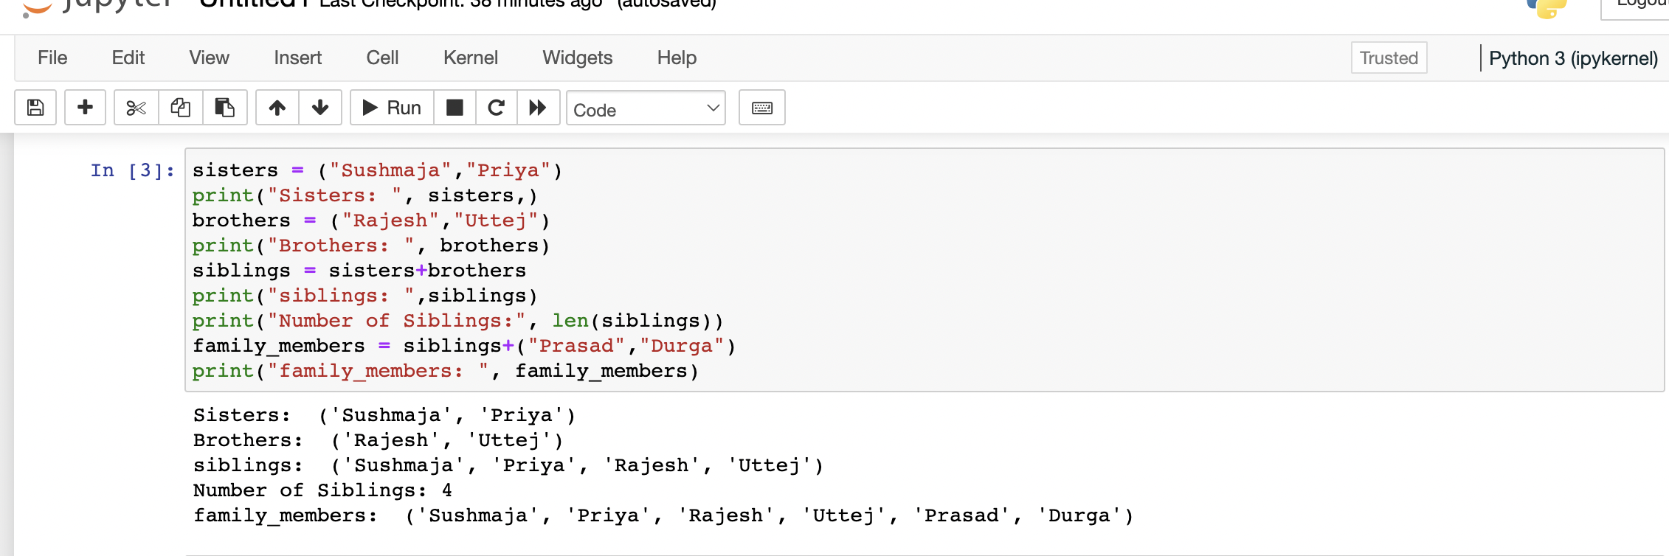

→I have created a tuple and given names of my brothers and sisters and join them and assigned them to siblings. I made modifications for the sibling tuple and added the name of my father and mother and assigned it as family_members.

**Q4) Length of the set**

it_companies = {'Facebook', 'Google', 'Microsoft', 'Apple', 'IBM', 'Oracle', 'Amazon'}

print("Length of Set it_companies:",len(it_companies))

#add(elements) adds elements into the set

it_companies.add('Twitter')

print("it_companies: ", it_companies)

it_companies.update(['Cognizant','LinkedIn','Salesforce','Wipro'])

print("it_companies after update: ",it_companies)

#remove() remove the element from the set

it_companies.remove("LinkedIn")

print(it_companies)

#Difference between remove and discard

print("\nDifference between Remove() and Discard(): Discard() method is different from the remove() method, because the remove() method will throw an error if the specified item is not present in list, whereas the discard() method will not throw any error if item doesn't exist in list.")

A = {19, 22, 24, 20, 25, 26}

B = {19, 22, 20, 25, 26, 24, 28, 27}

#all set operation can be performed in set: union(), intersection()

print("\nUnion of A and B sets: ",A.union(B))

print("Intersection of A and B sets: ",A.intersection(B))

#issubset() returns true if it is subset of other else false

print("A is Subset of B? ",A.issubset(B))

#to check is A and B are disjoint sets ( no elements in common)

print("A and B are disjoint sets? ",A.isdisjoint(B))

print("(AUB) AND (BUA): ",(A.union(B)).intersection(B.union(A)))

#checking symmetric differece .. return the extra elements of set A that are not in B

print("Symmetric Difference of A with B: ",A.symmetric_difference(B))

#clear() clear/ delete all elements from set

A.clear()

B.clear()

print("After clear Set A values: ", A,"\tSet B values: ",B)

age = [22, 19, 24, 25, 26, 24, 25, 24]

print("\nage list: ",age)

age_set = set(age)

print("set of ageslist: ", age_set)

print("Length of age list: ", len(age), "\nLength of age set",len(age_set))

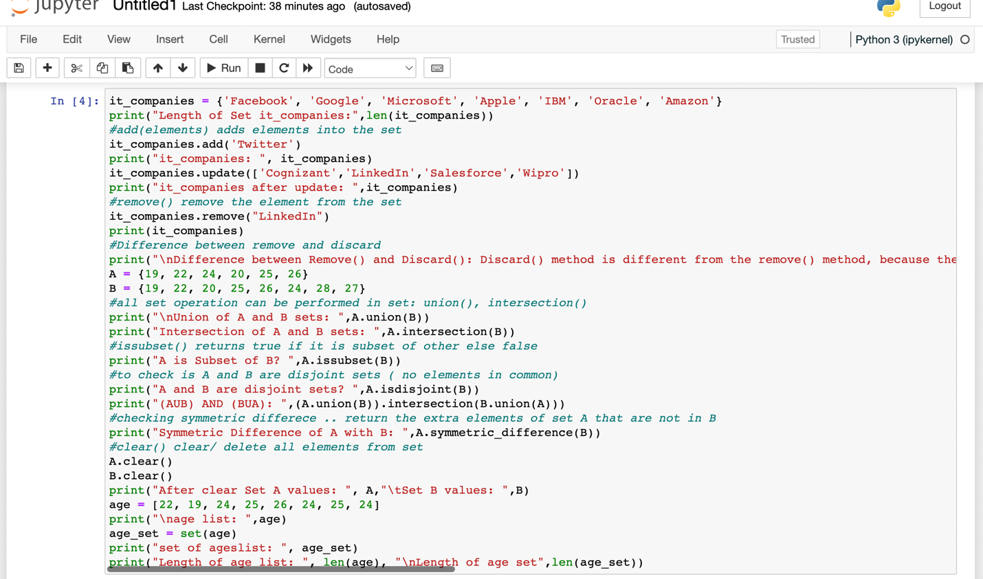

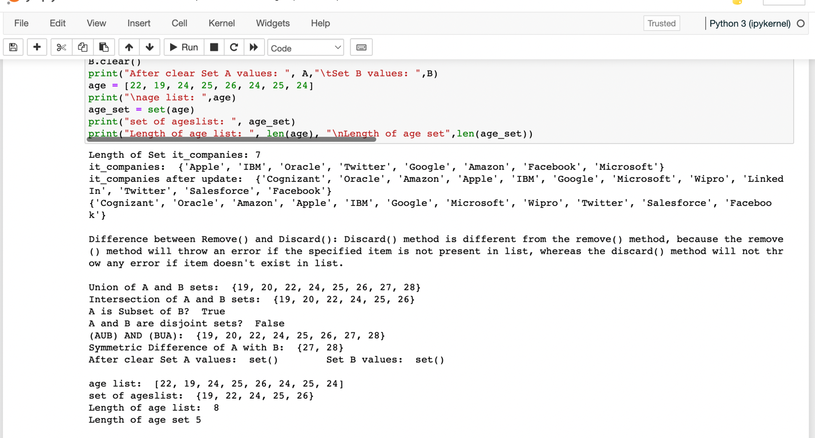

I have found the length of the set it_companies and added twitter to the set it_companies and also inserted multiple IT companies to the set it_companies and differentiated the remove and discard. Then joined the tuples A and B and found the A and B intersection and found that if A subset of B then the looking at if A and B are disjoint sets and the joined the A with B and B with A and finding the symmetric difference between A and B and then deleting the sets completely and converted the ages to a set and compare the length of the list and the set.

**Q5) Calculate area of circle and circumference of circle**

from math import pi

radius_of_circle = 30

_area_of_circle_ = pi * radius_of_circle **2

print("Area of a circle = ",_area_of_circle_," meters square")

_circum_of_circle_ = 2 * pi * radius_of_circle

print("Circumference of a circle = ",_circum_of_circle_, ' meters')

_radius_of_circle_ = float(input("Enter radius of circle: "))

_area_of_circle_ = pi * _radius_of_circle_ **2

print("Area of a circle = ",_area_of_circle_," meters square")

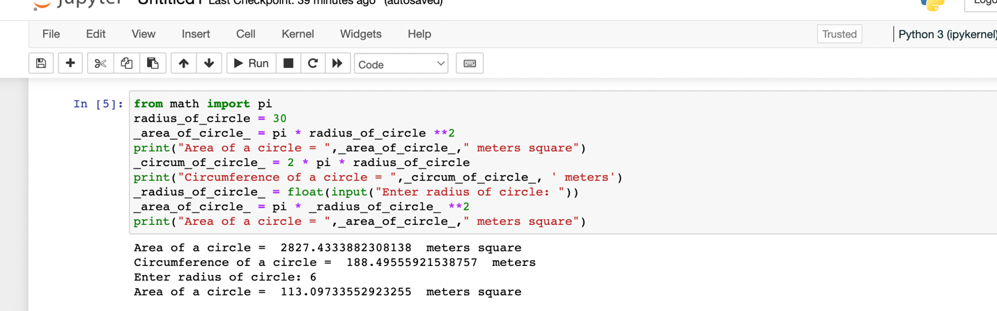

→In the program, we are trying to find the area and circumference of a circle by mentioning the radius

**Q6) Unique words using split method**

print("I am a teacher and I love to inspire and teach people")

set_words = set(("I am a teacher and I love to inspire and teach people".split(" ")))

print("Number of Unique words: ",len(set_words), set_words)

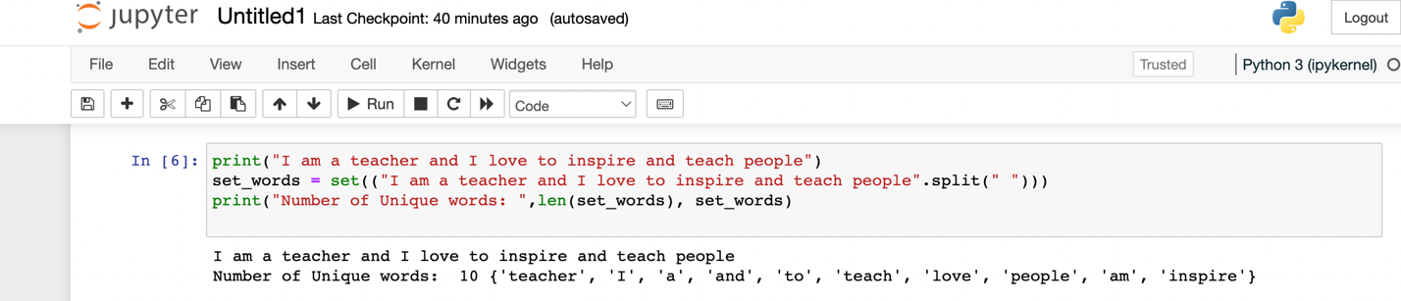

→The above program is to find the count of unique words in a string. I have considered the string “I am a teacher and I love to inspire and teach people” from which the count of unique words is found. Used a set to convert the list into a set.

**Q7) Used tab and escape to display them in the given format**

text = "\033[1m Name \t Age \tCountry City\n Asabench 250 \tFinland Helsinki\033[0m"

print(text)

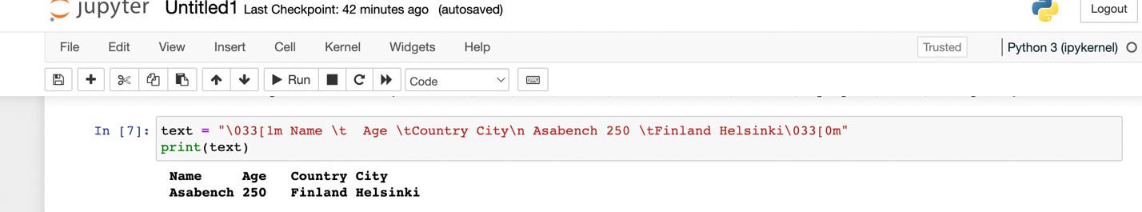

→the name, age, country and city of a person is being printed. I have considered the name as asabeneh, age25, country as finland and city is Helsinki.

**Q8**) **Use the string formatting method to display the following:**

radius = 10

area = 3.14 * radius ** 2

print("The area of a circle with radius",radius,"is %.0f" %area, "meters square.")

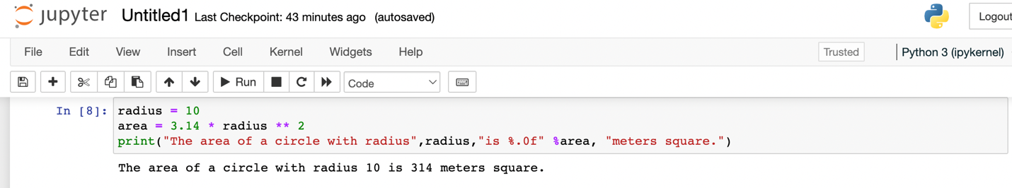

→here we are trying to find the area of a circle with the radius of 10 using the area of circle formula

**Q9) Write a program, which reads weights (lbs.) of N students into a list and convert these weights to kilograms in a separate list using Loop. N: No of students (Read input from user)**

#1lb = 0.453592kg

number_of_students = int(input("Enter number of students: "))

weight_of_students_lbs = list() #to store weights in lbs

weight_of_students_kgs = list() # to store weights in kgs

for each in range(number_of_students):

weight_lb = int(input("Enter weight of {} student in lbs: ".format(each+1)))

weight_of_students_lbs.insert(each, weight_lb)

#converting lbs to kg and adding to seperate list

weight_kg = float("%.2f" %(weight_lb*0.453592))

weight_of_students_kgs.insert(each, weight_kg)

print("weight of students in lbs: ",weight_of_students_lbs)

print("weight of students in kgs: ",weight_of_students_kgs)

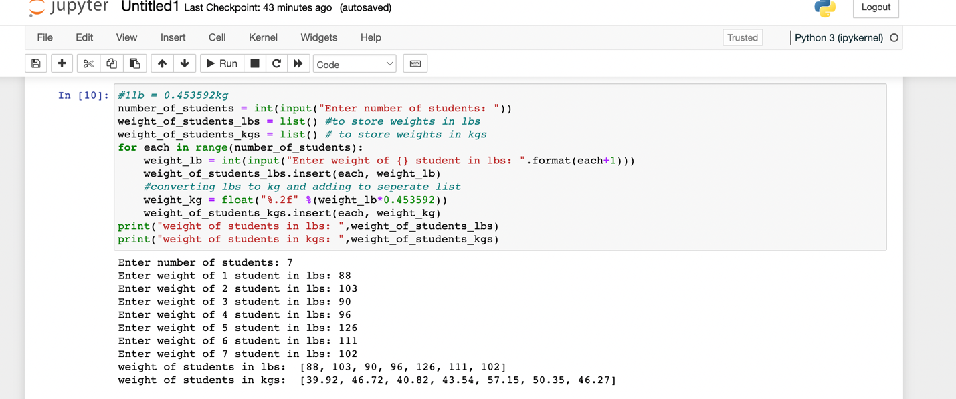

→the weight of the students converted from Lbs to kgs using python. We have to enter the number of students post which we will have to enter the weight of students in Lbs. after entering the weight, it’ll be converted to kg.

**Q10)**

import numpy as nm

import pandas as pd

from sklearn.model_selection import train_test_split

from sklearn.preprocessing import StandardScaler

from sklearn.neighbors import KNeighborsClassifier

from sklearn.metrics import confusion_matrix

X= nm.array([[1,0],[2,0],[3,0],[6,0],[6,0],[7,0],[10,0],[11,0]])

print("Dataset with total 8 points: \n",X,"\n Size: ",len(X))

y = nm.array([0,0,1,1,1,0,0,0])

print("\nClass label for the datasetX Y:",y)

x_train, x_test, y_train, y_test= train_test_split(X, y, test_size= 0.50, random_state=0,shuffle=False )

print("\nTraining Data X: \n", x_train)

print("\nTraining Data label Y:", y_train)

#feature Scaling-used to normalize the range of independent variables or features of data.

#i.e.to standardize the data prior to performing classification

stand_scalar= StandardScaler()

x_train= stand_scalar.fit_transform(x_train)

x_test= stand_scalar.transform(x_test)

#Initialising KNN Classifier with value 3\n",

classifier= KNeighborsClassifier(n_neighbors=3)

#Fitting the data to classifier

classifier.fit(x_train, y_train)

#Predict Labels for x-test data\n",

y_pred= classifier.predict(x_test)

print('\nPredicted Classs labels for testing data Y:',y_pred)

#Confusion matrix with tested data

confusion_matrix_result = confusion_matrix(y_test, y_pred)

print("\nConfusion Matrix\n",confusion_matrix_result)

#total P+N can be calculated using sum(sum(conf_matrix))

total_value = sum(sum(confusion_matrix_result))

#Accuracy TN+TP / P+N

accuracy=(confusion_matrix_result[0,0]+confusion_matrix_result[1,1])/total_value

print ('\nAccuracy : ', accuracy)

#Sensitivity TP/(TP+FN)

sensitivity = confusion_matrix_result[1,1]/(confusion_matrix_result[1,0]+confusion_matrix_result[1,1])

print('Sensitivity : ', sensitivity )

#Specificity TN/(TN+FP)

specificity = confusion_matrix_result[0,0]/(confusion_matrix_result[0,0]+confusion_matrix_result[0,1])

print('Specificity : ', specificity)

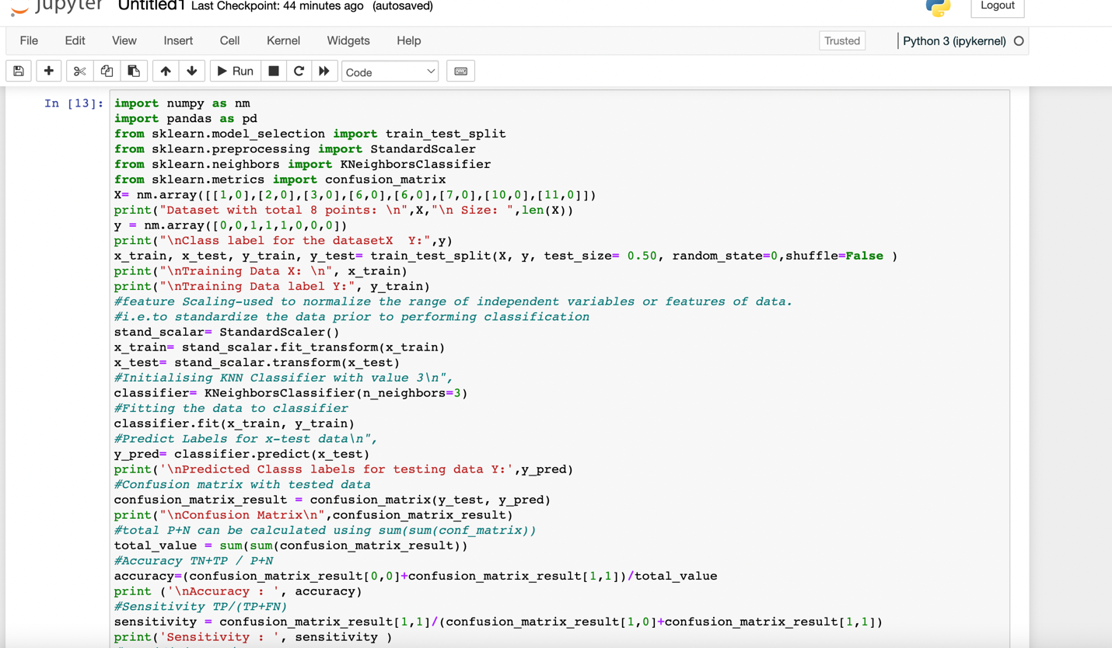

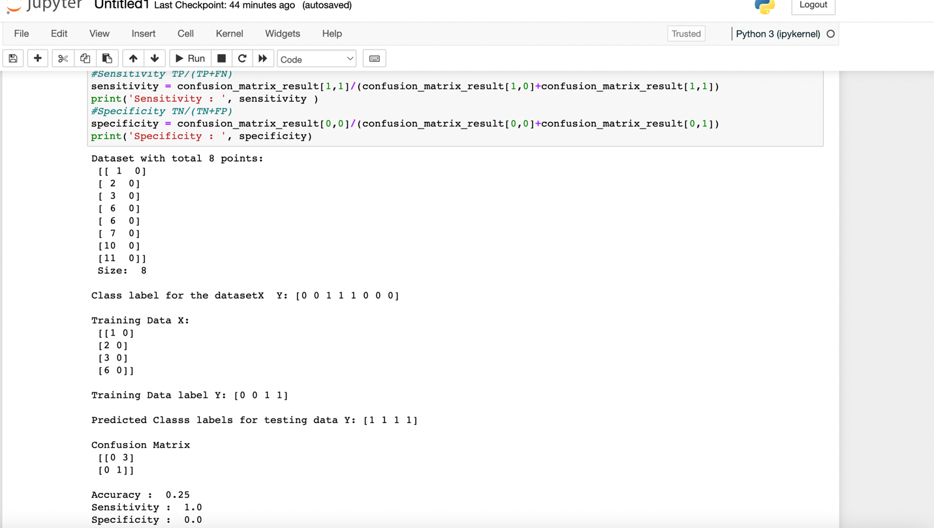

Video link: https://drive.google.com/file/d/1PQ7-dQS145wCwtE8PYuLLnafOJteLi-5/view?usp=sharing